Picture | Name & Price | Detailed Characteristics
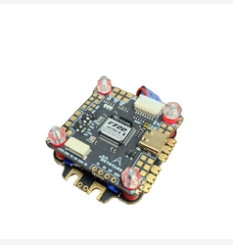 | Skystars F7HD Stack F722HD Pro 5 OSD & AM60 AM32 4in1 ESC - 30 x 30mm  127.49$
 | HDZero Radio Controller - ELRS 250mW  59.99$
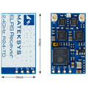 | MATEK ELRS-R24-TD ExpressLRS 2.4GHZ True Diversity Receiver  32.99$
 | Gemfan Hurricane 7" Street League Spec 7043-3 PC Durable Tri-Blade Propellers - 2CW+2CCW- Choose Color  4.99$ (x8 39.92$)
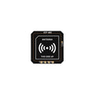 | GEPRC GEP-M10 GPS Module  25.99$
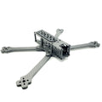 | PYRODRONE SOURCE ONE 7" Long Range Frame - 6mm V2.0 Deadcat Arms  38.99$
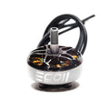 | Emax ECO II Series 2807-1300KV Motor  19.49$ (x4 77.96$)

